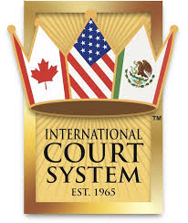
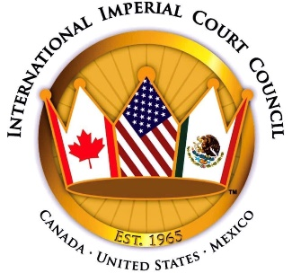
50 Emperors of Distinction

2021 marks the 50th Anniversary of the crowning of the 1st Emperor within the Imperial Court System, Greg Lucio of Long Beach. In commemoration of this historic event, Queen Mother 1 of the Americas Nicole the Great would like to celebrate and honor the achievements of 50 outstanding Emperors across the Americas, and highlight the diversity of the International Imperial Court System.
Nominees should be living Emperors that have made a distinguished impression on their court and community. Did the Emperor’s service to the court create a lasting change and bring honor to the local or international court system? Did the Emperor’s community service create a lasting impact on the LGBTQ+ communities? Did the Emperor’s personal life’s achievements bring greater good to the lives of others?
We invite Court Governing Boards and College of Monarchs to nominate their peers for this honor. Any current Court Member may also submit nominations. Please keep in mind that this is not a competition. A distinguished panel of Empresses representing the various courts in the realm will review all nominations submitted, and make their recommendations for final selection to the Queen Mother 1 Nicole the Great and King Father 1 Terry Sidie.
Please use this application to submit your nomination, which is a fillable Word document format; and must include a professional, high-resolution color headshot in regal attire. The deadline for nomination is Friday, April 30. Nominations should be emailed to Her Majesties Lord High Chancellor, Duncan Stewart at milczar1@yahoo.com.
A webpage will be created shortly at the ICC website. Additional information will also be available at the ICC Facebook page. For further information or questions, please email cocolachine7@gmail.com.
Thank you for your attention and participation,
Empress Coco LaChine, New York
Chair, 50 Emperors of Distinction

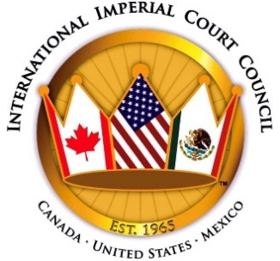
50 Emperors of Distinction Form

Nomination form:
Please use this fillable word document, click on each answer area and type in the information requested. The deadline for submission is April 30th 2021, and nominations with supporting documentation should be emailed to Lord High Chancellor Duncan Stewart at milczar1@yahoo.com.

Nominee Information

Emperor’s Name: Type here
Years with Court: Type here
Name of Court: Type here
Legal Name: Type here
Phone Number: Type here
Email Address: Type here

Nomination Submitted by:

Name: Type here
Phone number: Type here
Email: Type here
Name of Court: Type here

Please indicate type of nomination:
Governing Board ☐ College of Monarchs ☐ Court Member ☐

About the Nominee:
In 500 words or less, please provide a short history of Court achievements and awards received (please do not include “Family titles”). You may also include a brief history of community service, affiliation with community organizations and community awards received. A maximum of eight (8) Letters of Endorsement, four Court and four Community, may be submitted as supporting documentation. Letters from the community and organizations are highly encouraged. Attach a professional, high-resolution color headshot in regal attire. Please do not imbed the photo in your document.
DO NOT SEND THE NOMINATION IN A PDF FORMAT.
Nominations should be emailed to Her Majesties Lord High Chancellor, Duncan Stewart at milczar1@yahoo.com. For further information or questions, please email cocolachine7@gmail.com.
Type here

